openSAP Evolved Web Apps with SAPUI5

**Week 1 Unit 2:** Developing in the Cloud with SAP Web IDE  
  
Exercises

PUBLIC



Table of ContentS

Developing in the Cloud with SAP Web IDE 3

Create an SAP Cloud Platform Developer Account 4

Navigate to your Web IDE Workspace 7

Configure the Service for SAP Fiori Launchpad 9

Connect to the Demo System ES5 15

Test the Development Environment 20

Deploy Project to Share it with the Outside World 25

RELATED MATERIAL 27

# Developing in the Cloud with SAP Web IDE

### Summary

In this unit, you’ll set up everything you need for the hands-on exercises in this course. You’ll get to know the development environment SAP Web IDE, configure your own SAP Fiori launchpad, and create a destination to the ES5 SAP Gateway demo system. Then, you’ll test everything by creating a “Pre-Flight Check” app. Finally, you’ll deploy your first app to the SAP Cloud Platform.

### Preview

After this exercise, the foundation is established for the rest of the course: The basic configuration is in place and has been tested, and you understand the corresponding concepts.

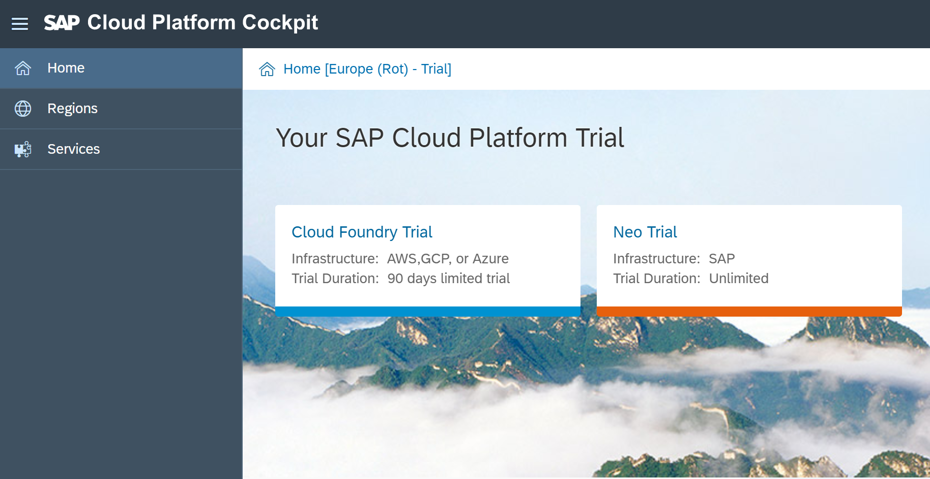

Figure 1 – The SAP Cloud Platform start page

## Create an SAP Cloud Platform Developer Account

| Explanation | **Screenshot** |
| --- | --- |
| 1. Open your browser, and open the following URL:   <https://account.hanatrial.ondemand.com/>  **Note: Use Google Chrome** We recommend that you use Google Chrome as a browser for this course, as it has the best developer tools. Our instructions and browser-related tips throughout this course will be refer to Google Chrome.  If you don’t have it installed yet, go to the following URL, and follow the setup steps: [**https://www.google.de/chrome/browser/desktop/**](https://www.google.de/chrome/browser/desktop/) |  |
| 1. Choose *Register* to create a free SAP Cloud Platform developer account. |  |
| 1. Enter your name and e-mail address, and choose a password (at least 8 characters long, including upper- and lowercase letters, numbers and symbols). 2. Accept the terms & conditions, and click *Register*.   **Note: Trial Account** This will create a developer account on SAP Cloud Platform for you with a free and perpetual [developer license](https://accounts.sap.com/ui/public/viewTextResource?scenario=SAP_HANA_Cloud_Developer_Edition&resourceType=RESOURCE_TERMS_OF_USE&locale=en_US&spDisplayName=SAP%20HANA%20Cloud%20Developer%20Edition). You can use this account to test out the platform or run demo scenarios. |  |
| 1. A confirmation e-mail has been sent to your account. Open it, and choose *Click here to activate your account*. |  |
| 1. You should see a confirmation dialog. Choose *Continue* to go to the SAP Cloud Platform Cockpit. |  |
| 1. Choose *Neo Trial*. |  |
| 1. In the Neo Trial environment, you can see a navigation frame on the left. This is your entry point for managing cloud apps and configurations.   **Note: How to keep track of your user**  Two sets of users and passwords are created in this unit:   * For the SAP Cloud Platform Developer Account (what we just did) * For the SAP Gateway Demo System ES5 (later in this unit)   If you are in doubt what your user is do this:   * SAP Cloud Platform Developer Account: On the top right side of the Cloud Platform Cockpit you can display your user. * SAP Gateway Demo System ES5: You’ll receive an e-mail with the temporary password. This you have to change immediately, of course, but the user will remain the same. |  |

## Navigate to Your SAP Web IDE Workspace

In this step, you’ll navigate to your workspace in SAP Web IDE.

| Explanation | **Screenshot** |
| --- | --- |
| 1. On SAP Cloud Platform, you can consume tools and applications as services.   Choose *Services* to see a list of applications that are available in your account. |  |
| 1. In the search field, filter for **ide**, and click on the  *SAP Web IDE Full-Stack* tile.   **Note: SAP Web IDE Full-Stack** Since December 31st, 2018, SAP Web IDE Full-Stack is the only cloud version of SAP Web IDE. It includes all capabilities for Grunt build, integration with SAP API Business Hub, as well as support for SAP Leonardo. |  |
| 1. Check the label underneath the title; if it reads *Not enabled*, choose *Enable*. If the label reads *Enabled* and the label is green, you can choose *Go to Service* in the *Take Action* area. |  |
| 1. SAP Web IDE opens. Have a look at the start page. It contains useful links and shortcuts to the most important actions. Choose *Open my workspace*.   The direct link to SAP Web IDE is https://webidecp-p[XXXXXXXXXX]trial.dispatcher.hanatrial.ondemand.com/  **Note:** Replace [XXXXXXXXXX] with your trial account user ID. If you are using an existing trial account, you will see a workspace with your other projects in this step. |  |
| 1. (Optional) Add a bookmark to SAP Web IDE Full-Stack by pressing *CTRL+D* in Google Chrome. You will need this link to your development environment frequently throughout the course, so you should bookmark the page. |  |

## Configure the Service for the SAP Fiori Launchpad

In this step you’ll configure the SAP Fiori launchpad in preparation for week 4 of the course.

| Explanation | **Screenshot** |
| --- | --- |
| 1. In your workspace, choose *Tools* 🡪 *SAP Cloud Platform* and then *Neo trial* to get to the SAP Cloud Platform Cockpit. |  |
| 1. Choose *Services* to see a list of applications that have been added automatically to your account. 2. Search for **Portal**. The Portal service is shown, but you can see that it’s marked as *Not enabled*. |  |
| 1. Choose *Not enabled* to go to the service configuration. 2. Choose *Enable*. |  |
| 1. As soon as the service is enabled, this is indicated at the top of the screen. 2. Choose *Go to Service* to continue with the configuration. |  |
| 1. In case your Portal Service brings up an authorization error,    * Go to the top right corner to get your user ID    * Go to Service, Portal, Configure Portal > Roles    * Rolle TENANT_ADMIN    * Assign to your user ID    * Log off    * Wait for about 5-10 minutes    * Log on again | cid:image001.png@01D4FE71.75F4E410 |
| 1. You can now see the SAP   Cloud Platform Portal site directory. This is where you will create your new launchpad site, so choose *Create New Site*. |  |
| 1. As the site name, enter **My Launchpad**. 2. Select *SAP Fiori Launchpad* as a template – you can find it by searching for **Fiori** in the search field. Then, click on the search result to select it. Only after the selection, the *Create* button at the bottom is enabled. Choose *Create*. |  |
| 1. Another browser tab is opened with the Fiori Configuration Cockpit for the new launchpad site *My Launchpad*.   **Note: Default Configuration Settings of *My Launchpad***  On the dashboard on the Home screen, you can see the default settings that came with the template you selected. You can change the settings with the options in the navigation panel on the left side. |  |
| 1. Result: If you go back to your previous browser tab, which is the *Site Directory*, you can see that a new launchpad site was added. |  |
| 1. Return to the launchpad configuration tab. Next, configure the launchpad catalog. Return to the *Fiori Configuration Cockpit*, and choose *Content Management* 🡪 *Catalogs*, or simply choose the *Catalogs* tile.   **Note:** A catalog is a set of apps you want to make available for a role. Depending on the role and the catalogs assigned to the role, users can browse through the catalogs and chose the apps that they want to display on the entry page of the SAP Fiori launchpad. |  |
| 1. To edit the *Sample Catalog*, choose *Edit* in the footer toolbar. | C:\Users\D038767\AppData\Local\Temp\SNAGHTML62cc0d.PNG |
| 1. On the *Properties* tab, change the name and the description to **My Applications**. |  |
| 1. Go to the *Roles* tab, and assign the role *Everyone* by selecting the check box. 2. Choose *Save*. | C:\Users\D038767\AppData\Local\Temp\SNAGHTML6201e7.PNG |
| 1. Go to *Groups*, and choose *Edit*. | C:\Users\D038767\AppData\Local\Temp\SNAGHTML6179fa.PNG |
| 1. Edit the *Sample Group*, rename it to **My Group** and choose *Save*. | C:\Users\D038767\AppData\Local\Temp\SNAGHTML28152b.PNG |
| 1. Click on the preview button in the top right corner to see your shiny new SAP Fiori launchpad | C:\Users\D038767\AppData\Local\Temp\SNAGHTML5c257a.PNG |
| 1. And here it is! It’s empty at this stage, as you don’t have any apps in your SAP Fiori launchpad yet, but all necessary background settings are made with a catalog and a group assigned to the role *Everyone*. You can now look forward to week 5, when you will fill your launchpad with apps! |  |

You have successfully created a basic SAP Fiori launchpad in preparation for week 5.

## Connect to the ES5 Demo System

In this step, you create an account with a user name and a password for the SAP Gateway demo system ES5. Then, you can configure a destination in the SAP Cloud Platform Cockpit.

**Note: SAP Gateway demo system ES5**With the below configuration, you can consume data from GWSAMPLE_BASIC and other demo services hosted publicly on the ES5 system. These sample services are typically based on the Enterprise Procurement Model containing entity types BusinessPartner, Contact, Product, SalesOrder and SalesOrderLineItem.

### Sign Up and Get Started with the SAP Gateway Demo Consumption System

| Explanation | **Screenshot** |
| --- | --- |
| 1. Start the SAP Gateway demo system with this URL https://register.sapdevcenter.com/SUPSignForms/ 2. If you see the log on screen, log on to your SAP Cloud Platform account. If you are already logged in you’ll see the SAP Gateway Demo Server welcome page. 3. Read the terms and conditions, and choose *Register*.   **Note: How to keep track of your user**  Two sets of users and passwords are created in this unit:   * For the SAP Cloud Platform Developer Account (what we did as first step) * For the SAP Gateway Demo System ES5 (what we’re doing here)   If you are in doubt what your user is do this:   * SAP Cloud Platform Developer Account: On the top right side of the Cloud Platform Cockpit you can display your user (see above). * SAP Gateway Demo System ES5: You received this e-mail with the temporary password. This you have to change immediately, of course, but the user will remain the same. |  |
| 1. If an upgrade for your trial account is necessary, you will see an additional step for this during your registration process. Read and acknowledge SAP’s privacy statement, and choose *Register*. |  |
| 1. You will see a success messagefor your registration. 2. Go to your e-mail inbox to find the confirmation e-mail, or follow the instructions on the screen to log on to the SAP Gateway WebGUI (<https://sapes5.sapdevcenter.com/>). |  |
| 1. Log on with your user name and temporary password. |  |
| 1. Change the password from a temporary to a permanent password. 2. **Write down the new password for the next configuration step.** |  |
| 1. The initial screen appears, which means your user ID and password work. You’re all set to create a destination in the SAP Cloud Platform Cockpit. This destination will then be the connection between the service and your app. |  |
| 1. To get to the SAP Cloud Platform Cockpit, go to your Web IDE Full-Stack trial account (use your bookmark, if have set it). 2. Go to *Tools* 🡪 *SAP Cloud Platform Cockpit*. |  |
| 1. In the SAP Cloud Platform Cockpit, choose *Connectivity* 🡪 *Destinations*. 2. Choose *Import Destination*. Leave the import popup open as you perform the next step. |  |
| 1. In another tab, download the *ES5 destination.txt* file from the UI52 GitHub repository folder *import* by right clicking the *Raw* button and choosing *Save Link as*…   [ES5 Destination on GitHub](https://github.com/SAP/openSAP-ui5-course/blob/master/import/ES5)  Save it to your local computer. Then select it in the import popup that appeared after you clicked on *Import Destination*. |  |
| 1. Ensure the field entries match the screenshot on the right side, and enter your user name and password for the SAP Gateway Demo System. 2. Choose *Save*.   **Note: Additional Properties**  WebIDEEnabled: This makes this destination visible to SAP Web IDE.  WebIDESystem: This is the system ID that the service runs on.  WebIDEUsage: You can enter multiple usages for a destination, separated by commas without spaces. |  |
| 1. This is the resulting destination configuration. Next, click on *Check Connection* to test if the URL is plausible.   **Note: *Check Connection* does not check user credentials**  An incorrect user or password does not cause this test to fail, because it only tests the URL connectivity, not the authentication to the system. |  |
| 1. If you see the message on the right, the test was successful, and the URL is correct. |  |

Note that this test is just a technical ping without authorization check. So, if you enter an incorrect password, this test will still be successful. For this reason, a test was added for the *Pre-Flight Check* app to see if you can retrieve a record through the service. If you get the record, the service works.

## **Test the Development Environment**

Let’s now check if our SAP Web IDE set-up works by adding the *Pre-Flight Check* example. From the SAP Cloud Platform Cockpit, go back to *Services*, find *SAP Web IDE Full-Stack* again, and re-open your workspace by choosing *Go to Service*.

| Explanation | **Screenshot** |
| --- | --- |
| Right-click on *Workspace*, and add a new project folder called **check**. |  |
| Repeat this step to create another new folder called **webapp**.  **Note: webapp folder**  The webapp foloder is not needed for the app to work but it’s part of the best practice for folder structure. The high-level folders should be webapp and test. The webapp folder should contain all the code that is related to the application. The test folder should contain all of the files needed for running automated tests for your application. |  |
| Right-click on the folder **webapp**, and choose *New* 🡪 *File* to create a new file called **index.html**.  Copy the code below into the newly created file and choose *Save.* |  |

check/index.html (NEW)

<!DOCTYPE HTML>

<head>

<meta charset="UTF-8">

<title>openSAP - Evolved Web Apps with SAPUI5</title>

<link rel="stylesheet" type="text/css" href="../../resources/sap/ui/core/themes/sap_belize/library.css">

<script id="sap-ui-bootstrap"

data-sap-ui-libs="sap.m"

src="../../resources/sap-ui-core.js"

data-sap-ui-theme="sap_belize">

</script>

<script>

// check javascript

document.addEventListener("DOMContentLoaded", function() {

document.getElementById("web").innerHTML = "Ready!";

});

// check ui5

sap.ui.getCore().attachInit(function() {

new sap.m.Title({

text: "Ready!"

}).placeAt("ui5");

document.getElementById("go").style.display = "block";

});

</script>

</head>

<body class="sapUiBody sapUiSmallMargin sapUiForceWidthAuto">

<h1>Evolved Web Apps With SAPUI5</h1>

<hr/>

<h2>Pre-flight Check</h2>

<ul>

<li><p><strong>Web Page:</strong></p>

<p id="web"></p></li>

<li><p><strong>SAPUI5:</strong></p>

<p id="ui5"></p></li>

<li><p><strong>Backend System:</strong></p>

<iframe id="es5" src="/ES5/sap/opu/odata/iwbep/GWSAMPLE_BASIC/VH_CountrySet('DE')?$format=xml" style="border:none; display: block"></iframe>

</li>

</ul>

<h2><span id="go" style="display: none; color: forestgreen">&rarr; All systems go – ready for take-off!</span></h2>

</body>

</html>

This page is intended to check some important things in our configuration:

* The head contains the UI5 bootstrap to make UI5 available. You test this by adding a UI5 element to your page. If it comes up, UI5 is ready.
* You check that JavaScript is enabled by means of the script tags.
* In the body, the iFrame contains a call to our ES5 service via the SAP Gateway demo system: It retrieves one record through your ES5 destination, the value for Germany. If the value is returned in a record, the test was successful.

Next, you make your destination available to your app by adding it to the neo-app.json file.

| Explanation | **Screenshot** |
| --- | --- |
| 1. Right-click on the your project root folder *check*, and choose *New* 🡪 *HTML5 Application Descriptor*.   **Note:** You will see this entry only if you right-click on the root folder of your project. |  |
| 1. This creates the neo-app.json file in your app folder. 2. Add the following destination information to it, and save your file. |  |

check/neo-app.json

|  |
| --- |
| {  "welcomeFile": "index.html",  "routes": [  {  "path": "/resources",  "target": {    ...    "description": "SAPUI5 Test Resources"  },  {  "path": "/ES5",  "target": {  "type": "destination",  "name": "ES5"  },  "description": "SAP Gateway Demo System"  }  ]  } |

Your workspace should now look like this:

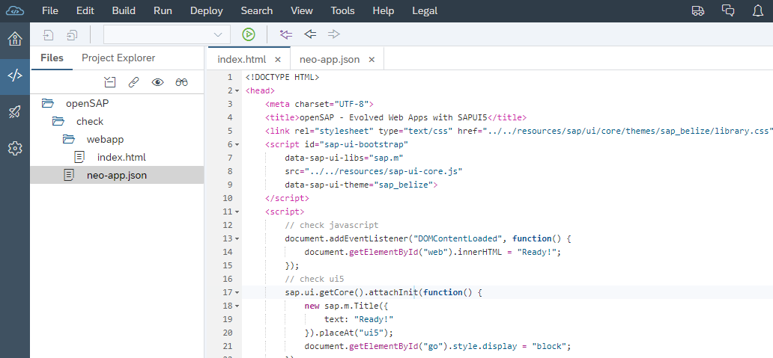

Figure 1 - Workspace for the test page

Remember to always save your changes by choosing the save icon(s) . You should also use the  preview button in the header toolbar from time to time. This will open a new tab with a preview of your app. Your “app” (remember: this is just a test) is now simulated in the cloud, and you will see the *Pre-Flight Check* app:

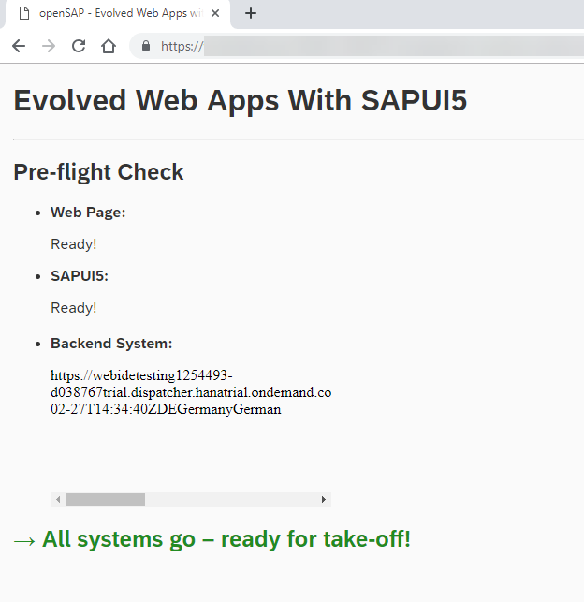

Figure 2 - Preview of the test page

Next, you’ll learn how to deploy and share the app on SAP Cloud Platform.

## **Deploy Project to Share it with the Outside World**

The link to a deployed app is accessible on the internet. Use it to illustrate technical issues or share your achievements with other learners.

### Deploy your App to SAP Cloud Platform

When previewing your app with the  button, you can conveniently test your local development. However, if you want to share your code, the local preview is not good enough. The URL is connected to your user session and won’t work for other learners.

check/neo-app.json

|  |
| --- |
| {  "welcomeFile": "check/index.html",  "routes": [  {  "path": "/resources",  "target": {  ... |

Before deploying the app, you need to configure the path so that SAP Cloud Platform can find the index.html file. In your SAP Web IDE workspace, (re-)open your neo-app.json file. Adjust the path for the welcome file by adding webapp/ in front of index.html. Now, the path matches the folder structure in your *webapp* folder.

Save the file by clicking on one of the buttons in the top left corner

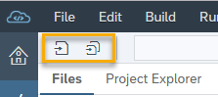.

| Explanation | **Screenshot** |
| --- | --- |
| 1. Next, you can deploy our app. Right-click the project folder, and choose *Deploy* 🡪 *Deploy to SAP Cloud Platform*. |  |
| 1. A settings window opens. You could change the name of your published app, give it a different version number, or deactivate it. For this exercise, use the default settings, and choose *Deploy*. |  |
| 1. Next, you get a pop-up with the success message and the links to the deployed app, which means it is accessible on the Internet via this link. Clicking on the first link will open the app. |  |
| 1. The second link displays the settings of your app in the SAP Cloud Platform Cockpit where you can manage all apps on your cloud account. | C:\Users\D038767\AppData\Local\Temp\SNAGHTML482f6e6.PNG |
| 1. When you click on the second link, you can see the app in the SAP Cloud Platform Cockpit. The publicly available link as well as the settings are all there. | C:\Users\D038767\AppData\Local\Temp\SNAGHTMLeedbf3.PNG |
| 1. After you close the pop-up, you can still find the links in SAP Web IDE by choosing *Tools* 🡪 *SAP Cloud Platform Cockpit*. |  |
| 1. Select *HTML5 Applications* in the navigation panel on the left side. Your *myapp* app is listed on the table. By clicking on it, you can see the same settings as you saw in step 5. |  |

In the next unit, you’ll learn how to set up a local development environment as an alternative to SAP Web IDE, how you can consume UI5, and how you can benefit from the latest UI5 Tooling.

# RELATED MATERIAL

* [Demo Kit: App Development Using SAP Web IDE](https://ui5.sap.com/#/topic/13ced9493472408999143bc99bbb73b9.html)